Logarithms Problem Sheet

1. Simplify, by removing logarithms
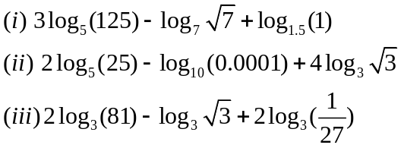

2. Evaluate the following expressions without using a calculator (or tables):
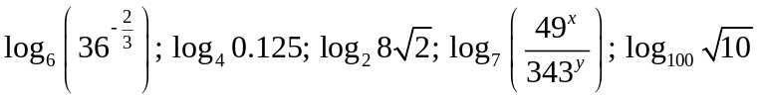
3. Evaluate the following expressions without using a calculator (or tables):
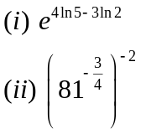

4. Solve the equations using logarithms. Simplify the answers, where possible.

5.

